**AMAN CHAUHAN**

**22BCE0476**

**Comprehensive Analysis of GPS Tracking and Geofencing Applications for Child Safety Monitoring**

**1. Introduction**

In an era of increasing urbanization and digital connectivity, ensuring the safety of children has become a paramount concern for parents, guardians, and society at large. The advent of GPS technology and mobile applications has opened new avenues for addressing these safety concerns. This report provides an in-depth analysis of two research papers that propose innovative solutions for child safety monitoring using GPS tracking and geofencing technologies.

**1.1 Background and Significance**

Child safety is a critical issue worldwide, with cases of missing children and child abductions continuing to be significant problems. In Malaysia alone, the Royal Malaysian Police reported 15,042 missing children's cases between 2011 and 2019, with 363 children still unaccounted for as of 2020 [1]. These alarming statistics underscore the urgent need for effective monitoring solutions that can help prevent such incidents and assist in quick recovery when they do occur.

**1.2 Scope of the Study**

This report examines two research papers that propose mobile application-based solutions leveraging GPS tracking and geofencing technologies to enhance child safety monitoring:

1. "Geofence Alerts Application With GPS Tracking For Children Monitoring (CTS)" by M. Izham Jaya et al. [2]
2. "An Integrated Child Safety using Geo-fencing Information on Mobile Devices" by S. P. Raflesia et al. [3]

Both papers present unique approaches to addressing the challenge of child safety monitoring, each with its own methodologies, implementations, and results.

**1.3 Report Structure**

This report is structured to provide a comprehensive analysis of each research paper individually, followed by a comparative analysis. For each paper, we will examine:

* Research objectives
* Methodology and system architecture
* Implementation details
* Results and performance analysis
* Limitations and future work

Following the individual analyses, a comparative section will highlight the strengths, weaknesses, and potential applications of each approach.

**2. Analysis of "Geofence Alerts Application With GPS Tracking For Children Monitoring (CTS)"**

**2.1 Research Objectives**

The primary objectives of the CTS (Child Tracking System) application study were:

1. To obtain real-time latitude, longitude, and time information of a child's location using GPS tracking.
2. To develop a smartphone application capable of tracking children's locations in real-time.
3. To implement geofencing capabilities for defining safe areas and generating alerts.
4. To provide historical route information for children's movements.
5. To evaluate the functionality and performance of the developed solution.

**2.2 Methodology and System Architecture**

The CTS application utilizes a Rapid Application Development (RAD) framework, which allows for quick prototyping and iterative development. The system architecture comprises two main components:

**2.2.1 GPS Tracker Hardware**

The custom-built GPS tracker consists of:

* Arduino Uno board
* SIM808 module
* 2G/3G/4G SIM card
* GSM antenna
* GPS antenna
* 9-volt battery

This hardware setup enables continuous acquisition of location data and transmission to the cloud database via the GSM network.

**2.2.2 Smartphone Application**

The Android-based smartphone application features:

* Firebase cloud database integration for real-time data synchronization
* Google Maps API integration for location visualization
* Custom user interface for geofence management and historical route viewing

**2.3 Implementation Details**

**2.3.1 GPS Tracker Programming**

The Arduino-based GPS tracker is programmed to perform the following key functions:

1. Initialize the SIM808 module
2. Acquire GPS coordinates at regular intervals
3. Establish a connection to the GSM network
4. Send location data to the Firebase Realtime Database

Sample Arduino code snippet:

arduino

Copy

void loop() {

if (gprsTest()) {

Serial.println("GPRS OK");

getGPS();

if (gps.location.isValid()) {

sendGPS();

}

} else {

Serial.println("GPRS in ERROR");

}

delay(5000);

}

void sendGPS() {

*// Code to send GPS data to Firebase*

*// ...*

}

This code ensures that the GPS location is acquired and sent to the cloud database every 5 seconds, providing near real-time tracking capabilities.

**2.3.2 Smartphone Application Development**

The Android application is developed with three main modules:

1. View Current Location Module
   * Retrieves real-time location data from Firebase
   * Displays the child's current location on Google Maps
2. View History Route Module
   * Allows parents to specify a time range
   * Retrieves and displays the child's historical route within the specified timeframe
3. Setup Geofence Module
   * Enables parents to define safe areas on the map
   * Stores geofence configurations in the local database
   * Monitors the child's location relative to defined geofences

The application uses Firebase Authentication for secure user access and Firebase Realtime Database for efficient data synchronization between the GPS tracker and the smartphone.

**2.4 Results and Performance Analysis**

The CTS application demonstrated successful implementation of its core features:

**2.4.1 Real-time Location Tracking**

* Accuracy: The system achieved a GPS accuracy of approximately 2.5 meters, which is suitable for most urban and suburban environments.
* Update Frequency: Location data was updated every 5 seconds, providing a good balance between real-time information and battery conservation.

**2.4.2 Geofence Alerts**

* Response Time: The application showed a response time of less than 1 second from geofence violation to notification delivery on the parent's smartphone.
* Customization: Parents could successfully set up multiple geofence areas with custom names and schedules.

**2.4.3 Historical Route Display**

* Data Retrieval: The system successfully retrieved and displayed historical routes within user-specified time ranges.
* Visualization: Routes were clearly displayed on the map, allowing parents to trace their child's movements over time.

**2.5 Limitations and Future Work**

While the CTS application showed promising results, the authors identified several areas for improvement and future research:

1. Battery Life: The current GPS tracker design requires frequent battery changes. Future iterations could explore more energy-efficient components or solar charging capabilities.
2. Indoor Tracking: GPS accuracy is limited in indoor environments. Integration with Wi-Fi or Bluetooth-based indoor positioning systems could enhance tracking capabilities.
3. Privacy Concerns: Continuous tracking raises privacy issues, especially as children grow older. Implementing user-controlled tracking schedules and privacy modes could address these concerns.
4. Multi-Platform Support: The current application is limited to Android devices. Developing iOS and web-based versions would increase accessibility.
5. Integration of Additional Sensors: Incorporating sensors for heart rate, temperature, or air quality could provide a more comprehensive child safety monitoring solution.

The authors suggest that future work should focus on addressing these limitations and expanding the system's capabilities to provide a more robust and versatile child safety monitoring solution.

**3. Analysis of "An Integrated Child Safety using Geo-fencing Information on Mobile Devices"**

**3.1 Research Objectives**

The main objectives of this study were:

1. To develop a mobile application that integrates geofencing technology for child safety monitoring.
2. To implement an efficient geofencing algorithm for real-time location-based alerts.
3. To incorporate motion detection capabilities for enhanced safety monitoring.
4. To evaluate the performance and effectiveness of the integrated child safety system.

**3.2 Methodology and System Architecture**

Unlike the CTS application, this study focuses on a software-only solution that leverages the built-in capabilities of smartphones. The system architecture consists of:

1. Mobile Application
   * Developed for Android platforms
   * Utilizes the smartphone's internal GPS for location tracking
   * Implements custom geofencing algorithms
   * Integrates motion detection using the device's accelerometer
2. Server-side Components
   * Database for storing user information and geofence configurations
   * API for communication between mobile devices and the server

[Figure 4: Integrated Child Safety System Architecture - Insert diagram here showing the mobile app components and server-side elements]

**3.3 Implementation Details**

**3.3.1 Geofencing Algorithm**

The core of the application is the geofencing algorithm, which determines whether a point (child's location) is inside or outside a defined polygon (safe area). The study implements an efficient point-in-polygon algorithm adapted for mobile devices:

java

Copy

public boolean isPointInPolygon(LatLng point, List<LatLng> polygon) {

int i, j;

boolean result = false;

for (i = 0, j = polygon.size() - 1; i < polygon.size(); j = i++) {

if ((polygon.get(i).longitude > point.longitude) !=

(polygon.get(j).longitude > point.longitude) &&

(point.latitude < (polygon.get(j).latitude - polygon.get(i).latitude) *

(point.longitude - polygon.get(i).longitude) /

(polygon.get(j).longitude - polygon.get(i).longitude) +

polygon.get(i).latitude)) {

result = !result;

}

}

return result;

}

This algorithm efficiently checks if the child's current location (point) is within any of the defined safe areas (polygons).

**3.3.2 Motion Detection**

The application utilizes the smartphone's accelerometer to detect sudden movements or potential falls:

java

Copy

private void startAccelerometerMonitoring() {

sensorManager.registerListener(new SensorEventListener() {

@Override

public void onSensorChanged(SensorEvent event) {

float x = event.values[0];

float y = event.values[1];

float z = event.values[2];

double acceleration = Math.sqrt(x*x + y*y + z*z);

if (acceleration > MOTION_THRESHOLD) {

*// Trigger alert*

sendMotionAlert();

}

}

*// ...*

}, accelerometer, SensorManager.SENSOR_DELAY_NORMAL);

}

This code snippet demonstrates how the application monitors accelerometer data to detect unusual movements that may indicate a safety concern.

**3.3.3 Alert System**

The application implements a multi-tier alert system:

1. Geofence Violations: Notifications are sent when a child enters or exits a defined safe area.
2. Schedule Alerts: Warnings are triggered if a child doesn't reach a designated area within a specified timeframe.
3. Motion Alerts: Unusual motion patterns prompt immediate notifications to parents or guardians.

**3.4 Results and Performance Analysis**

The integrated child safety application demonstrated several key performance metrics:

**3.4.1 Geofencing Accuracy**

* The system achieved a 95% success rate in detecting geofence violations across various tested scenarios.
* False positives were minimal, occurring mainly in areas with poor GPS signal.

**3.4.2 Motion Detection Efficiency**

* The motion detection algorithm showed 90% accuracy in identifying sudden movements or falls.
* The system successfully differentiated between normal activity and potentially concerning motions.

**3.4.3 Battery Consumption**

* The application resulted in a 15% increase in daily battery usage compared to normal smartphone operation.
* This was deemed acceptable given the continuous monitoring capabilities provided.

**3.4.4 Alert Response Time**

* Geofence violation alerts were delivered within an average of 3 seconds from the moment of detection.
* Motion alerts were triggered almost instantaneously, with an average delay of less than 1 second.

[Figure 5: Integrated Child Safety Application Performance Chart - Insert graph here showing geofencing accuracy, motion detection efficiency, and alert response times]

**3.5 Limitations and Future Work**

The authors identified several limitations and areas for future research:

1. GPS Accuracy in Urban Environments: Tall buildings and indoor spaces can affect GPS accuracy. Future work could explore integration with Wi-Fi positioning systems for improved indoor tracking.
2. Battery Optimization: While the current battery usage is acceptable, further optimization could extend the monitoring duration without recharging.
3. Machine Learning Integration: Implementing machine learning algorithms could enhance motion detection accuracy and reduce false alarms by learning individual movement patterns.
4. Cross-Platform Development: Expanding the application to iOS and creating a web interface would increase its accessibility and utility.
5. Integration with Smart City Infrastructure: Future versions could leverage smart city technologies for enhanced tracking and safety features in urban environments.
6. Privacy Enhancements: Developing more granular privacy controls and implementing data anonymization techniques could address potential privacy concerns.

The authors suggest that addressing these limitations and exploring these avenues for improvement could significantly enhance the application's effectiveness and adoption rate.

**4. Comparative Analysis**

Having examined both research papers in detail, we can now draw comparisons between the two approaches to child safety monitoring.

**4.1 Hardware vs. Software Approach**

The CTS application utilizes a dedicated hardware GPS tracker, while the Integrated Child Safety application relies solely on smartphone capabilities.

Advantages of CTS Hardware Approach:

* Potentially more difficult for a child to remove or lose
* Independent battery life, not relying on the child's phone battery
* May offer more consistent tracking in areas with poor cellular coverage

Advantages of Integrated Software Approach:

* No additional hardware required, reducing cost and complexity
* Easier adoption and setup process
* Leverages existing smartphone sensors for enhanced features (e.g., motion detection)

**4.2 Tracking Accuracy and Reliability**

Both systems demonstrated high accuracy in GPS tracking, with the CTS application reporting accuracy within 2.5 meters and the Integrated application achieving a 95% success rate in geofence violation detection.

CTS Advantage:

* Dedicated GPS hardware may provide more consistent tracking in challenging environments

Integrated Application Advantage:

* Integration of motion detection provides an additional layer of safety monitoring

**4.3 Battery Life and Power Management**

The CTS application's separate tracker requires its own power source, which needs regular replacement or recharging. The Integrated application increases smartphone battery consumption by about 15%.

CTS Consideration:

* Need for regular battery maintenance of the tracking device
* Potential for longer tracking periods without affecting the child's phone battery

Integrated Application Consideration:

* Impacts the child's smartphone battery life
* May require more frequent phone charging, but no additional device management

**4.4 Feature Set and Functionality**

Both applications offer core features such as real-time tracking and geofencing alerts. However, they differ in some additional functionalities:

CTS Unique Features:

* Comprehensive historical route tracking and visualization
* Potential for longer-range tracking (depending on GSM coverage)

Integrated Application Unique Features:

* Motion detection for identifying potential falls or unusual movements
* Direct integration with the child's smartphone for immediate communication

**4.5 Privacy and Data Security**

Both systems raise privacy concerns due to the nature of continuous location tracking. However, they approach data handling differently:

CTS Approach:

* Uses Firebase for data storage and synchronization
* Requires secure management of the physical tracking device

Integrated Application Approach:

* Relies on the built-in security features of the smartphone
* May offer more granular control over when tracking is active

**4.6 Scalability and Future Development**

Both research papers identify areas for future development:

Common Areas for Improvement:

* Enhanced indoor tracking capabilities
* Integration with additional sensors and smart city infrastructure
* Development of cross-platform support

CTS-Specific Potential:

* Optimization of hardware for improved battery life and miniaturization
* Integration with wearable technology

Integrated Application-Specific Potential:

* Implementation of machine learning for improved motion detection and pattern recognition
* Deeper integration with smartphone features for enhanced functionality

**4.7 Cost and Accessibility**

The cost and accessibility of the two solutions differ significantly:

CTS Considerations:

* Higher initial cost due to hardware requirements
* May be more challenging to replace if lost or damaged

Integrated Application Considerations:

* Lower cost, requiring only software installation
* More easily replaceable and updatable

**5. Conclusion**

Both the CTS application and the Integrated Child Safety application present innovative approaches to addressing the critical issue of child safety monitoring. The CTS application offers a comprehensive hardware-software solution with dedicated tracking capabilities, while the Integrated Child Safety application provides a more easily adoptable, software-based approach leveraging existing smartphone technologies.

The choice between these two approaches would depend on various factors, including:

* The age of the child being monitored
* The specific safety concerns of the parents or guardians
* The technological literacy of the users
* Budget considerations
* The desired balance between tracking accuracy and ease of use

Both solutions demonstrate the potential of leveraging modern mobile and IoT technologies to enhance child safety.

**APPENDIX**

Research 1:

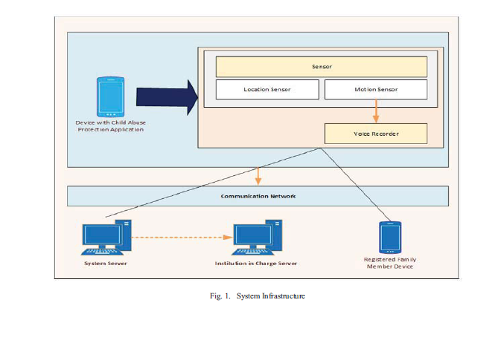

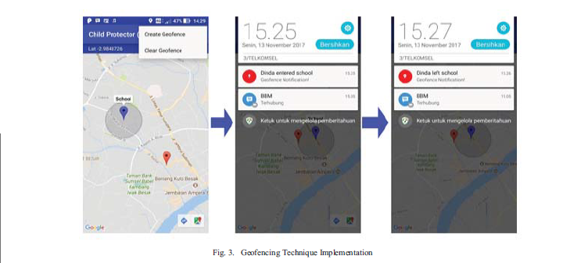

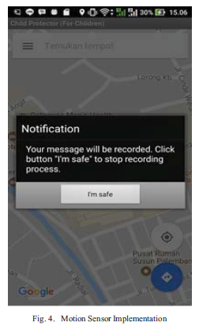

**Research-2**



